**Climate Change vs. Civilization**

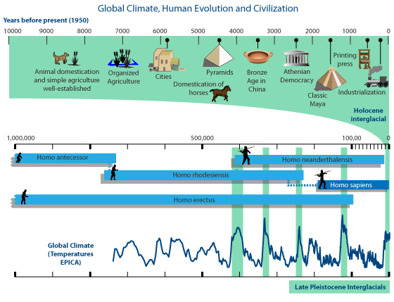

See Next Chart

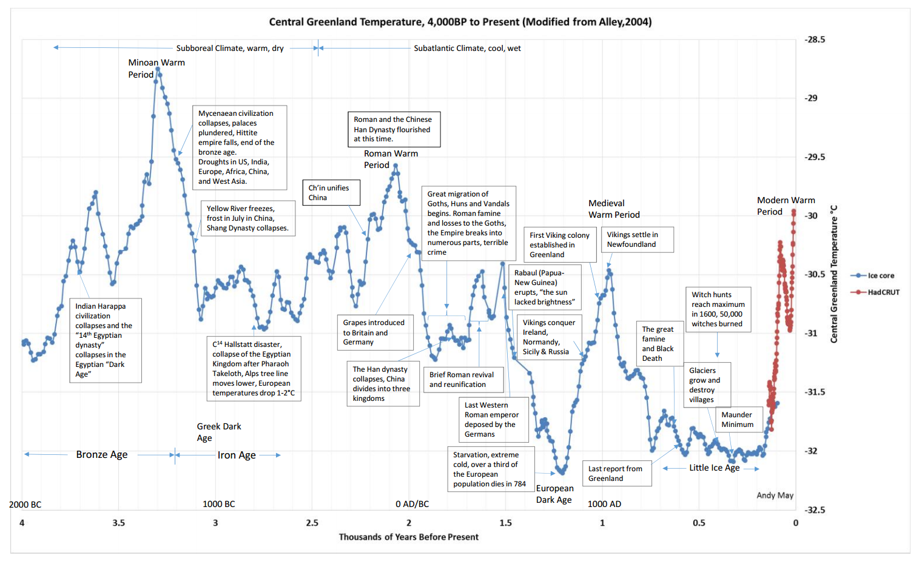

On page one are two charts. Your task is a simple CER. Examine the two charts and determine whether there is a connection or relationship between climate, change in climate, and/or civilization. Write a CER (at least one paragraph) that contains your claim, at least 3 pieces of evidence from the charts, and explain how each piece of evidence supports your claim using reasoning derived from what you have learned in class. Feel free to supplement your evidence and reasoning with properly referenced and cited research on the topic. Ensure to end your CER with a conclusion or summary. Your CER needs to be **AT LEAST** 5 sentences (1 for the claim, at least 1 for each piece of evidence/reasoning, and 1 concluding/summary sentence.)

|  |
| --- |
|  |